**THEORY OF PROGRAMMING LANGUAGES**

**GROUP MEMBERS:**

-Nashra Ghaffar (CT-032)

-Muhammad Abdul Rafay (CT-012)

**COURSE CODE:** CT-367

**SUBMITTED TO:** SIR KAMRAN

**TABLE OF CONTENTS**

**1. INTRODUCTION**

1.1 Objectives

**2. IMPORTANCE OF JAVASCRIPT LANGUAGE**

2.1 Introduction to JavaScript

2.2 JavaScript in Software Development

2.3 JavaScript in Mobile App Development

2.4 JavaScript in Game Development

2.5 JavaScript in IoT Applications

2.6 JavaScript in Data Visualization

2.7 JavaScript in Artificial Intelligence and Machine Learning

**3. FUTURE SCOPE**

3.1 Enhanced Features

3.2 Integration with Other Languages

3.3 Optimization and Performance

3.4 Integration with Development Environments

3.5 Support for Other Input Formats

**4.Components**

4.1 Flex: Tokenizing and Identifying Comment Patterns

4.2 Bison: Generating Par*ser Rules for Comment Detection*

**5. RESULTS**

5.1 Results

**6. DISCUSSION**

6.1 Expansion to Accommodate Advanced Features

6.2 Integration with Different Languages

6.3 Optimization and Performance Improvements

6.4 Integration with Development Environments

6.5 Support for Diverse Input Formats

**7. CONCLUSION**

**1. INTRODUCTION**

This report aims to document the creation of a parser generator that utilizes Flex and Bison to identify commented code, both single-line and multi-line comments, within the JavaScript language. The document presents the project's objectives, describes the tools employed, examines the importance of JavaScript in the implementation, and delves into the potential for future advancements.

**1.1 Objectives**

The main objectives of this project are:

I. Develop a parser generator for detecting comments in JavaScript code to enable efficient identification and differentiation of single-line and multiline comments.

II. Provide a user-friendly interface to define grammar rules for comment structures in JavaScript.

III. Generate a parser capable of handling complex JavaScript code with various comment types, including support for multiline comments spanning multiple lines and single-line comments.

IV. Implement a robust error handling mechanism to address syntax errors related to comments and provide informative error messages to aid in debugging.

V. Generate an output indicating the type of comment detected (single-line or multiline) within the JavaScript code, facilitating further analysis or processing.

***2. Importance of JavaScript Language***

JavaScript has emerged as a versatile programming language that extends its influence far beyond web development. With its widespread adoption and continuous evolution, JavaScript has become a cornerstone technology in various domains, ranging from software development to Internet of Things (IoT) applications. This document explores the significance of JavaScript beyond its traditional use in web development and highlights its diverse applications across different industries.

**2. 1 Introduction to JavaScript**

JavaScript, often abbreviated as JS, is a dynamic programming language known for its ability to add interactivity and functionality to web pages. Originally developed for web browsers, it has evolved into a multipurpose language with a vast ecosystem of frameworks, libraries, and tools. JavaScript's versatility and flexibility have opened up new avenues for its utilization across different domains.

**2.2 JavaScript in Software Development**

JavaScript has gained popularity in software development due to its ability to build cross-platform applications. With frameworks like Node.js, JavaScript can now run on servers, enabling developers to create backend systems and APIs. This shift has empowered JavaScript to be used in full-stack development, facilitating efficient and consistent code sharing between the frontend and backend.

**2.3 JavaScript in Mobile App Development**

The advent of frameworks like React Native and Ionic has made JavaScript a popular choice for developing mobile applications. These frameworks allow developers to build native mobile apps using JavaScript, resulting in code reusability and faster development cycles. JavaScript's extensive library support and community contributions further contribute to its viability in mobile app development.

**2.4 JavaScript in Game Development**

JavaScript has become a formidable player in the game development realm. With frameworks such as Phaser and Pixi.js, developers can create captivating and interactive games directly in the browser. The combination of HTML5, CSS3, and JavaScript has revolutionized browser-based gaming, making it accessible to a wider audience.

**2.5 JavaScript in IoT Applications**

JavaScript's lightweight nature and compatibility with embedded systems have led to its adoption in IoT development. JavaScript frameworks like Johnny-Five and Cylon.js simplify the process of interacting with hardware devices, enabling developers to build IoT applications with ease. JavaScript's ubiquity also makes it an ideal choice for prototyping and rapid iteration in the IoT space.

**2.6 JavaScript in Data Visualization**

Data visualization plays a crucial role in understanding complex information. JavaScript libraries like D3.js and Chart.js offer powerful tools for creating interactive and visually appealing charts, graphs, and maps. JavaScript's ability to manipulate the Document Object Model (DOM) in real-time allows for dynamic and responsive data visualizations.

**2.7 JavaScript in Artificial Intelligence and Machine Learning**

The rise of JavaScript libraries such as TensorFlow.js and Brain.js has brought machine learning and artificial intelligence capabilities to JavaScript developers. These libraries enable developers to train and deploy models directly in the browser, democratizing access to AI technologies and fostering innovation in JavaScript-based applications.

***3. Future Scope***

The future scope of the project focused on detecting comments in JavaScript code includes the following possibilities:

**3. 1. Enhanced Features:**

- Expansion to support advanced comment structures, such as nested or conditional comments.

- Detection of comment-related patterns, such as comment tags or annotations, to provide additional functionality for developers.

**3. 2. Integration with Other Languages:**

- Creating language-specific bindings or interfaces to incorporate the comment detection parser into projects written in different programming languages.

- Enabling cross-language compatibility and facilitating seamless integration of the parser generator in various development environments.

**3. 3. Optimization and Performance:**

- Improving parsing speed and memory efficiency of the generated parser code through optimization techniques like JIT compilation or runtime optimizations.

- Enhancing the overall performance of the comment detection process for large-scale JavaScript codebases.

**3. 4. Integration with Development Environments:**

- Integrating the comment detection parser generator into popular development environments or IDEs.

- Providing features such as syntax highlighting, code completion, and error checking specifically tailored for comment detection in JavaScript code.

**3. 5. Support for Other Input Formats:**

- Extending the parser generator's capabilities to detect and handle comments in other input formats, such as configuration files, markup languages, or data serialization formats.

- Expanding the tool's versatility and applicability beyond JavaScript comment detection.

By pursuing these potential future developments, the comment detection parser generator can evolve into a more powerful and adaptable tool. It will enable developers to efficiently identify and differentiate between single-line and multiline comments in JavaScript code, while also offering opportunities for integration, optimization, and support for diverse programming languages and input formats.

***4. Components***

The development of the parser generator comprised the following crucial elements:

***4.1 Flex:***

Flex plays a vital role in detecting different types of comments in JavaScript code. By defining rules that match specific comment patterns, Flex tokenizes the input code into distinct comment tokens such as "COMMENT_START," "COMMENT_END," "COMMENT_LINE," or "OTHER" (for non-comment characters). This enables the subsequent parsing and analysis of comments in the Bison code.

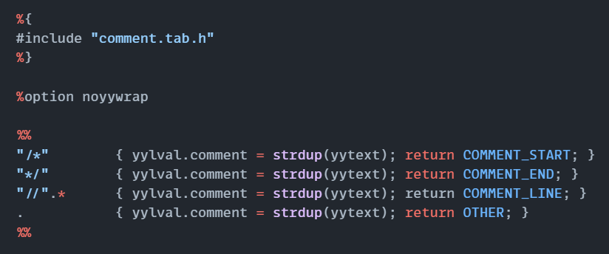

**EXPLANATION**

**1. Section 1 - Header Section**

- Description: This section includes the necessary header files and any other preprocessor directives required for the Flex code.

- Rules: The inclusion of "comment.tab.h" header file using the "#include" directive.

**2. Section 2 - Flex Options Section**

- Description: This section defines specific options for the Flex lexer.

- Rules: The declaration of the "noyywrap" option using the "%option" directive.

**3. Section 3 - Lexical Rules Section**

- Description: This section contains the lexical rules that define patterns and corresponding actions to be taken when those patterns are matched.

- Rules:

- The rule matching the start of a multiline comment with "/*" and returning the corresponding token "COMMENT_START".

- The rule matching the end of a multiline comment with "*/" and returning the corresponding token "COMMENT_END".

- The rule matching a single-line comment starting with "//" and any subsequent characters until the end of the line, returning the token "COMMENT_LINE".

- The rule matching any other character with ".", returning the token "OTHER".

**4. Section 4 - Lexical Analysis Rules**

- Description: This section specifies the overall structure and behavior of the lexical analysis performed by Flex.

- Rules: The use of "%%" to separate the lexical rules section from the rest of the code.

***4.2 Bison:***

Bison plays a pivotal role in the project by generating a parser based on the provided grammar rules. It takes the tokenized input from the Flex lexer and applies the grammar rules to determine the structure and behavior of the comments in the JavaScript code. Bison enables the identification of different types of comments and specifies the actions to be taken when encountering each type. It facilitates the overall parsing and processing of comments, ensuring proper output and error handling.

**BISON CODE:**

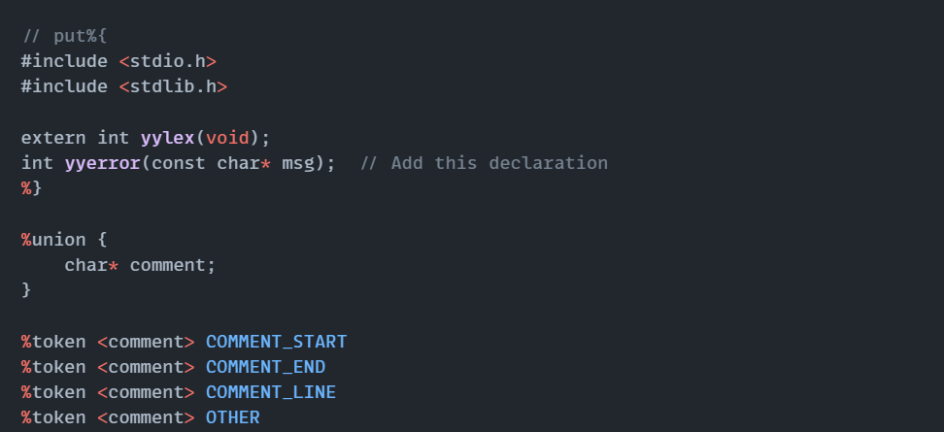

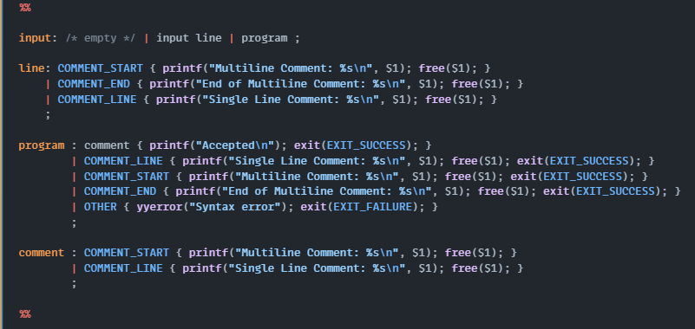

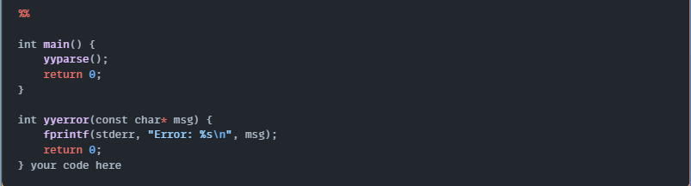

**EXPLANATION:**

**1. Section 1 - Header Section**

- Description: This section includes necessary header files and any other preprocessor directives required for the Bison code.

- Rules: The inclusion of "stdio.h" and "stdlib.h" headers using the "#include" directive.

**2. Section 2 - External Declarations**

- Description: This section declares the external lexer function `yylex()` and the error handling function `yyerror()`.

- Rules:

- The declaration of the external lexer function `extern int yylex(void);`.

- The declaration of the error handling function `int yyerror(const char* msg);`.

**3. Section 3 - Union Declaration**

- Description: This section defines the union type used for semantic values in the Bison grammar.

- Rules: The declaration of the union type `char* comment` using `%union`.

**4. Section 4 - Token Definitions**

- Description: This section defines the token types to be used in the grammar rules.

- Rules:

- The definition of token `<comment>` with types `COMMENT_START`, `COMMENT_END`, `COMMENT_LINE`, and `OTHER` using `%token <comment>`.

**5. Section 5 - Start Symbol Definition**

- Description: This section specifies the start symbol for the grammar.

- Rules: The specification of the start symbol as `input` using `%start`.

**6. Section 6 - Grammar Rules**

- Description: This section contains the grammar rules specifying the structure and behavior of the parser.

- Rules:

- The definition of the `input` rule, allowing for an empty input, multiple lines, or a program.

- The definition of the `line` rule, which handles different types of comment lines.

- The definition of the `program` rule, which handles comment-only programs or specific comment types.

- The definition of the `comment` rule, which handles comments within other constructs.

**7. Section 7 - Main Function**

- Description: This section contains the main function that invokes the parser generated by Bison.

- Rules:

- The invocation of the `yyparse()` function to start the parsing process.

**8. Section 8 - Error Handling Function**

- Description: This section contains the implementation of the error handling function `yyerror()`.

- Rules:

- The definition of the `yyerror()` function that handles and reports syntax errors.

***5. RESULTS***

The implementation of the parser generator yielded the following results:

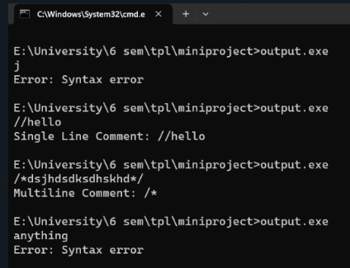

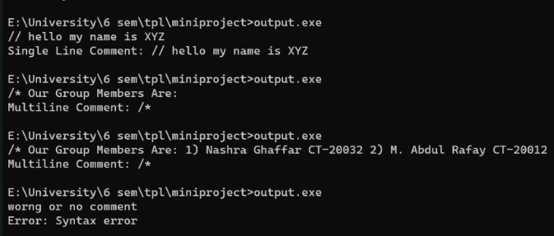

***6. DISCUSSION***

The development of a parser generator for detecting comments in the JavaScript language using Flex and Bison opens up several avenues for future enhancements and expansions. These include:

**6.1 Expansion to Accommodate Advanced Features**

There is potential to extend the parser generator to handle more intricate comment structures, such as nested or conditional comments. This would enhance its capability to effectively handle complex commenting scenarios in JavaScript code.

**6.2 Integration with Different Languages**

By providing language-specific bindings or interfaces, the generated parser can be integrated into projects written in various programming languages. This allows developers to leverage the comment detection capabilities of the parser generator within their preferred programming language, broadening its applicability beyond JavaScript.

**6.3 Optimization and Performance Improvements**

Future work can focus on optimizing the performance of the generated parser code to improve parsing speed and memory efficiency. Exploring techniques like just-in-time (JIT) compilation or runtime optimizations can lead to enhanced overall performance in detecting comments.

**6.4 Integration with Development Environments**

Integrating the parser generator with development environments or IDEs would provide developers with tailored features such as syntax highlighting, code completion, and error checking specific to comment detection in JavaScript code. This integration significantly enhances the developer experience and streamlines the process of identifying and managing comments within the codebase.

**6.5 Support for Diverse Input Formats**

While the current focus lies in detecting comments in JavaScript code, extending the parser generator to support parsing and processing comments in other input formats, such as configuration files, markup languages, or data serialization formats, would increase its versatility and usefulness across various scenarios.

**7. CONCLUSION**

In conclusion, the development of a parser generator for detecting comments in the JavaScript language using Flex and Bison provides a valuable tool for efficiently identifying and distinguishing between single-line and multiline comments. The combination of Flex and Bison, in conjunction with the power of the JavaScript language, enables the creation of a robust and effective parser generator. The future prospects involve expanding its feature set, exploring integration possibilities, optimizing performance, and extending support for additional input formats. Overall, this parser generator represents a significant contribution to comment detection and language processing, offering extensive applications in code analysis, documentation generation, and software development.